**Jarods Asset Documentation**

* Original mockups
  + The original mockups of the characters and scenes where made with pencil and paper. Following that, I scanned them and imported those images into a program called Gimp which is essentially like photoshop.
  + The images were then traced using Gimps drawing tools and colored.
* The character design
  + Following our plans for character creation and basing it somewhat off of Mii characters, I decided to try utilizing a pixel art style to allow different parts of the characters could snap together like a puzzle.
  + The art was made using a website called pixilart. I created a 50x25 sized grid to begin working towards creating the character. I then spent a long time working through shapes and lengths to get a good idea for the character outline.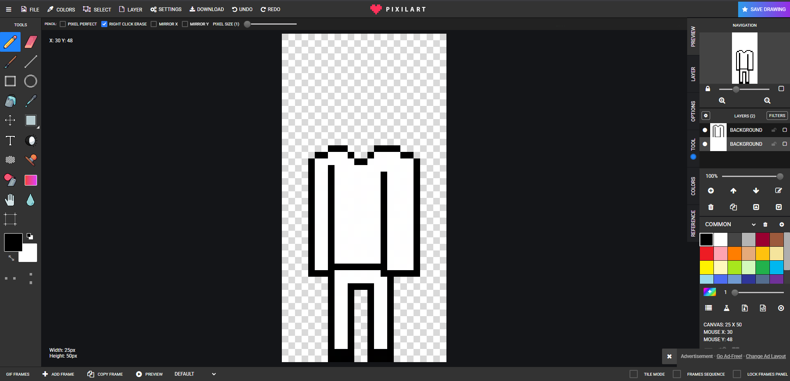
* The details
  + Once I had a basic shaped character made, I began to add details such as where the clothes meet the neck, hands and feet. Then I created facial details.
  + I had this saved as a template file to be used going into the future.
  + Once I had the base character created, the easiest details to add next was the lab coat and glasses. These parts of the character were not varied by styles and colors so only one model even needed to be made for them.
  + I then moved on to the hair. I didn’t want to spend too long on this because I wanted to get everything working before adding more details. So to start out I only added short hair and a ponytail.
  + The final element I had to add was male and female elements. I was not sure on the best way to go about this, especially with limited resources. I finally decided to add eyelashes to distinguish between the two.
* The colors
  + The colors wound up becoming the most time consuming part of these assets. I began with skin tones and found a basic library of skin colors within the websites color pallet selection.
  + I kept a document holding these hex values should I need to come back and make alterations.
    - Ffe0bc, eac086, c68742, 613c24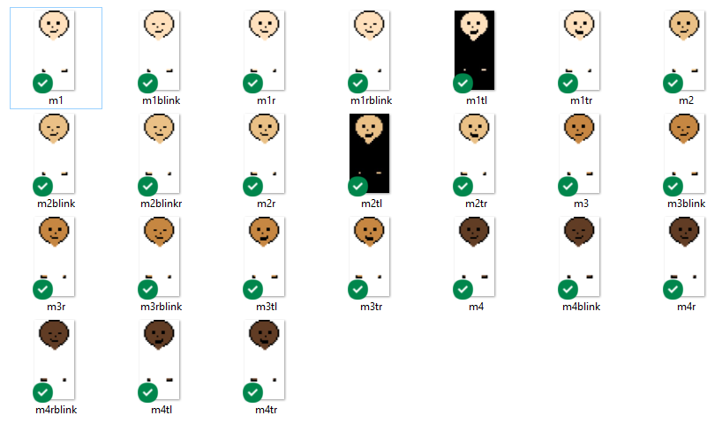
  + One of my largest mistakes was never making documentation of the hex values for any other colors. I eventually did for hair and clothes very late into the project when it was needed using Gimps color dropper tool and have it commented in the code for reasons I’ll get to later.
  + I decided to only use mostly natural hair colors for the time being otherwise there would have been a much larger library during implementation. Black, blonde, brown, orange, and red. I had to create these color hair styles for both the ponytail and short hair.
  + Next was the scrubs. I decided to just get the maximum amount of colors done all at once so I wouldn’t have to come back later. 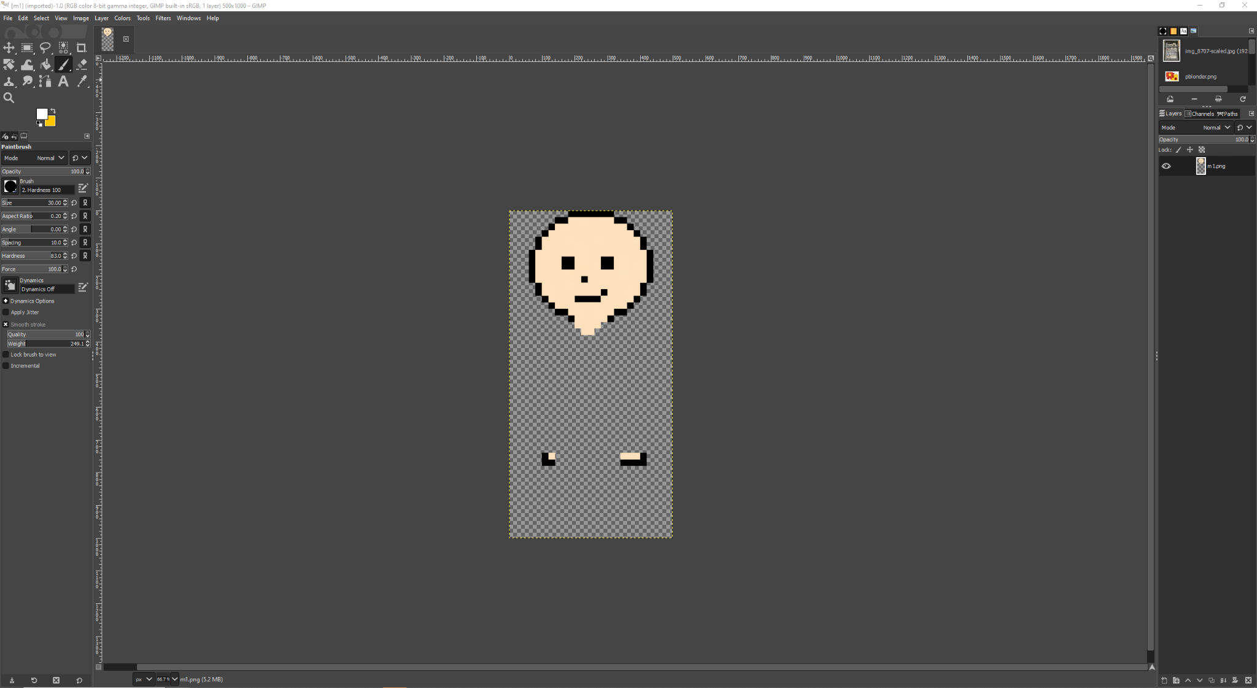
* Implementing
  + Once creating all color materials, I then had to make the material in unity. I exported all the different parts a 1000x500 sized image for better quality. I then created a 2D plane object in unity to house the material. I started off with skin on the bottom layer, then hair and clothes above that, then the lab coat and glasses above that. Each layer is within a fraction away from each other giving the illusion that they are on the same plane. 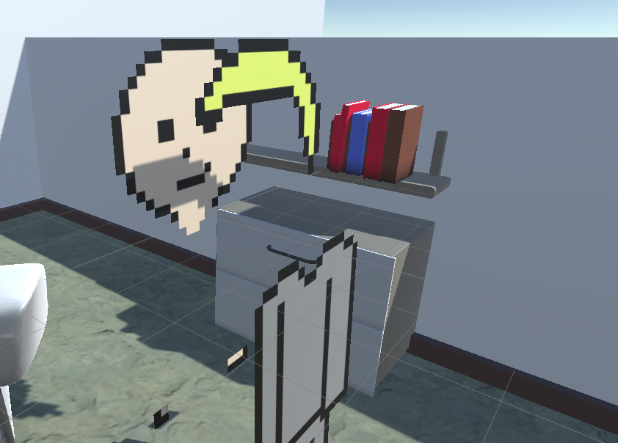
  + Then the character creator just switches out each different material
* The animations
  + In order to make animations for the player looking the opposite direction, I dragged the initial images and flipped them horizontally and gave them a new material.
  + For the walking animations, I brought the clothes images back into the pixilart website and created two frames with one leg up by one pixel and the other leg up by another pixel and looped the swapping of those materials when the player is holding onto one of the movement keys.
* The revision
  + We discovered that it saves us a lot of space by just manipulating the colors of 1 set material and changing its hex value. I was able to implement this into the animations but the other materials were hard coded into the character creation screen and could not be changed without revising the entire system.
* The music
  + The music for the level selection screen was downloaded from a royalty free website called pixabay.
  + The rest of the music in the game I made in FLStudio 11 a couple years ago. I didn’t have time to make new music so I just used what I found in a folder.